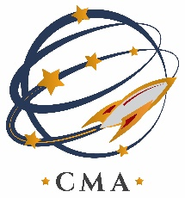

**COLORADO MILITARY ACADEMY**

**Board of Directors Meeting**

**May 10, 2022**

**4:30 p.m.**

**Colorado Military Academy**

**360 Command View, Colorado Springs, Colorado 80915**

**CMA’s mission is to prepare cadets for today’s colleges and tomorrow’s careers by engaging cadets in a rigorous and high-tech curriculum in science, technology, engineering, and math (STEM) while building strong moral character through an environment of military leadership development.**

**AGENDA**

1. Call to Order: Roll Call
2. Approve Agenda

III. Approve Minutes of April 12, 2022 Board Meeting

IV. Public Comment (max 3 min each)

V. Board Work Session Items:

a. Board members to make comments if they like before the work take place.

b. Update from the Principal

c. Update from the Commandant

d. Update from the Director of Staff

e. Update from the Board Action Officer

f. Update from the Comptroller

VI. Action Items:

1. Vote on the financial reports
2. Nominations on board member positions
3. CMA Employee Handbook first read
4. Approval of Course Catalog
5. Approval of D-11 letter

VII. Executive Session: No executive Session

IX. Other Business:

1. Next Board Meeting June 14, 2022

X. Adjourn