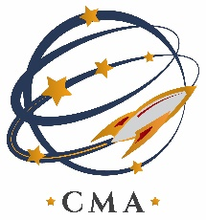

**COLORADO MILITARY ACADEMY**

**Board of Directors Notice of Meeting**

**August 19, 2021**

**6:00 P.M.**

**Colorado Military Academy**

**360 Command View, Colorado Springs, CO 80915**

**Contact us at** [**info@cmacs.org**](mailto:info@cmacs.org) **for information.**

**CMA’s mission is to prepare cadets for today’s colleges and tomorrow’s careers by engaging cadets in a rigorous and high-tech curriculum in science, technology, engineering, and math (STEM) while building strong moral character through an environment of military leadership development.**

**AGENDA**

1. CMA Board Dinner Meeting with AMCSUS
   1. Discussion about potential American Military Colleges and Schools in the U.S. (AMCSUS) membership.